Student Name: SELINA MOMOI

Admission Number: BBIT/2024/74407
Course/Class: BBIT
Unit Code: BIT3208

Unit Name: Advanced Web Design and Development
Lecturer Name: MR MICHEAL NYORO
Academic Year: 3.2

Project Title: Viatubora E-Commerce System
Selected Technologies: PHP + MySQL, Bootstrap 5 (HTML/CSS)
GitHub Link:

Contents
WEEK1: Installation and Testing of Local Development Environment 1
Fig 1: Installation of XAMPP/WAMP 1
Fig 2: Apache and MySQL Running 1
Fig 3: Localhost Test Page 2
Fig 4: Hello World Test 2
Fig 5: Database Connection Test 2
WEEK2: User Interface Planning and System Design 3
Fig 6: Wireframe (Homepage for ViatuBora) 3
Fig 7: Dashboard Layout Design 3
Fig 9: Color Theme and Navigation Structure 4
Fig 10: GUI Prototype in Canva 4
WEEK3: Frontend Interaction and Backend Foundations 5
Fig 11: JavaScript Form Validation (e.g., preventing empty submissions on ViatuBora login) 5
Fig 12: Password Strength Checker 5
Fig 13: PHP Syntax Practice 6
Fig 14: Database Connection Script 7
Fig 15: Dynamic User Input Handling 7
WEEK4: System Authentication and Session Management 8
Fig 16: User Registration Flow (register.php) 8
Fig 17: Secure Login Script (login.php) 9
Fig 18: Role-Based Redirection (Admin vs. Customer) 9
Fig 19: Session Initialization and Management 9
WEEK5: Designing the Product Catalog Database 10
Fig 20: Database Schema design in phpMyAdmin 10
Fig 21: Add Product Form (add-product.php) 11
Fig 22: Inventory Dashboard displaying database records (dashboard.php) 11
Fig 23: Edit and Delete functionalities (edit-product.php) 11

WEEK1: Installation and Testing of Local Development Environment

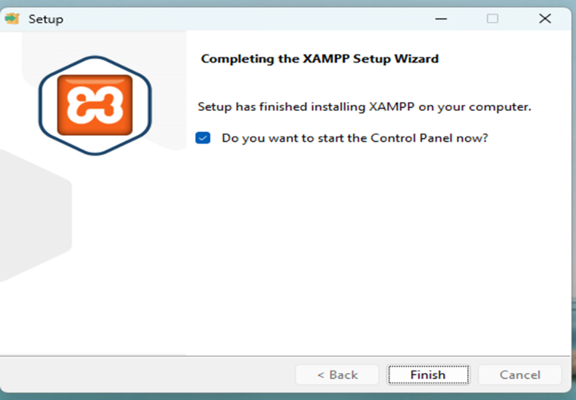

Fig 1: Installation of XAMPP/WAMP
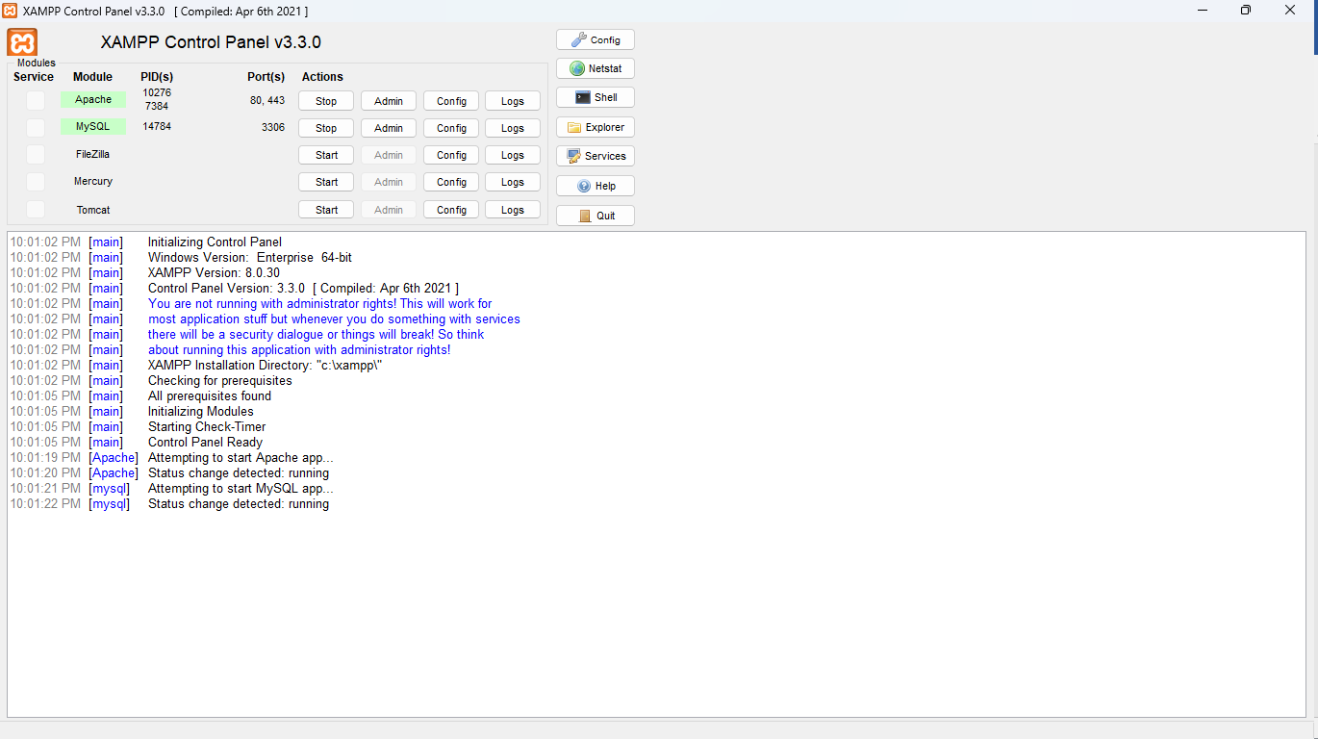

Fig 2: Apache and MySQL Running
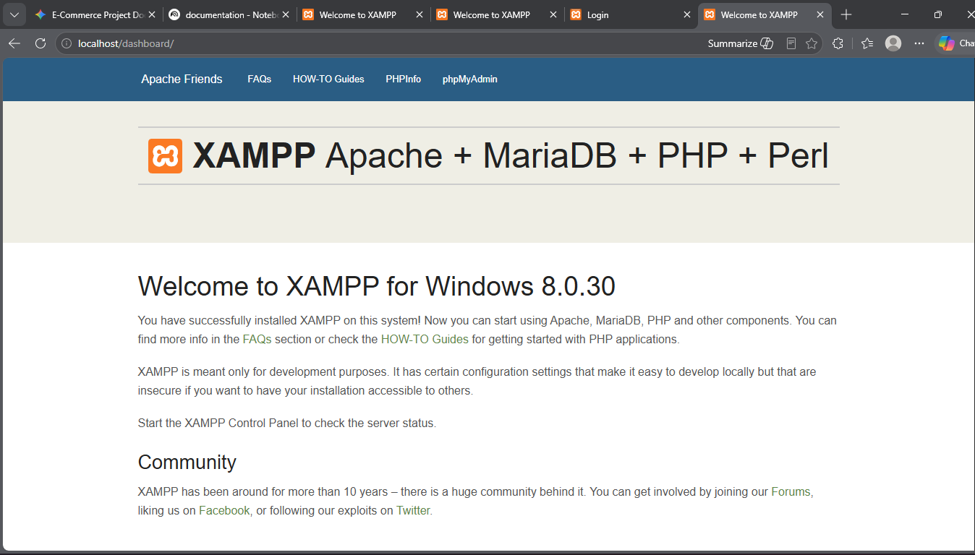

Fig 3: Localhost Test Page
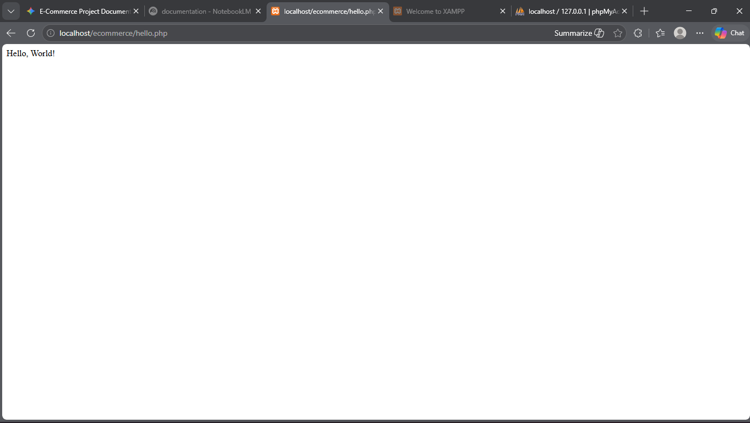

Fig 4: Hello World Test

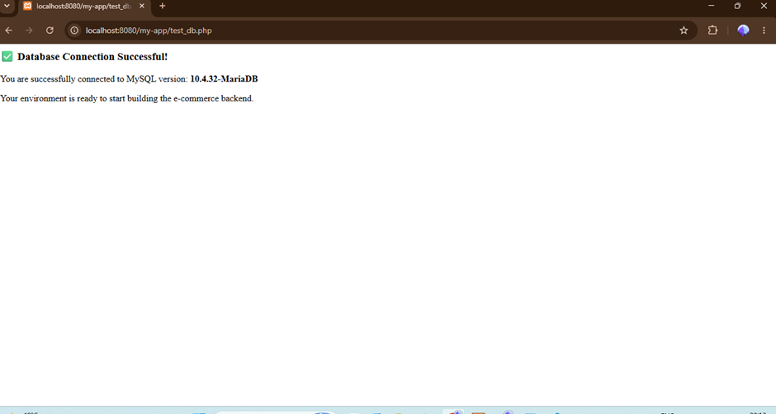

Fig 5: Database Connection Test

During this week, I set up a local development environment (XAMPP) to host the ViatuBora e-commerce platform. Fig 5 shows a successful connection between PHP and MySQL using PDO in db.php. This confirmed that Apache and MySQL services were properly configured in XAMPP. Establishing this database connection was critical for the foundation of the multi-tier architecture required for the ViatuBora system

WEEK2: User Interface Planning and System Design

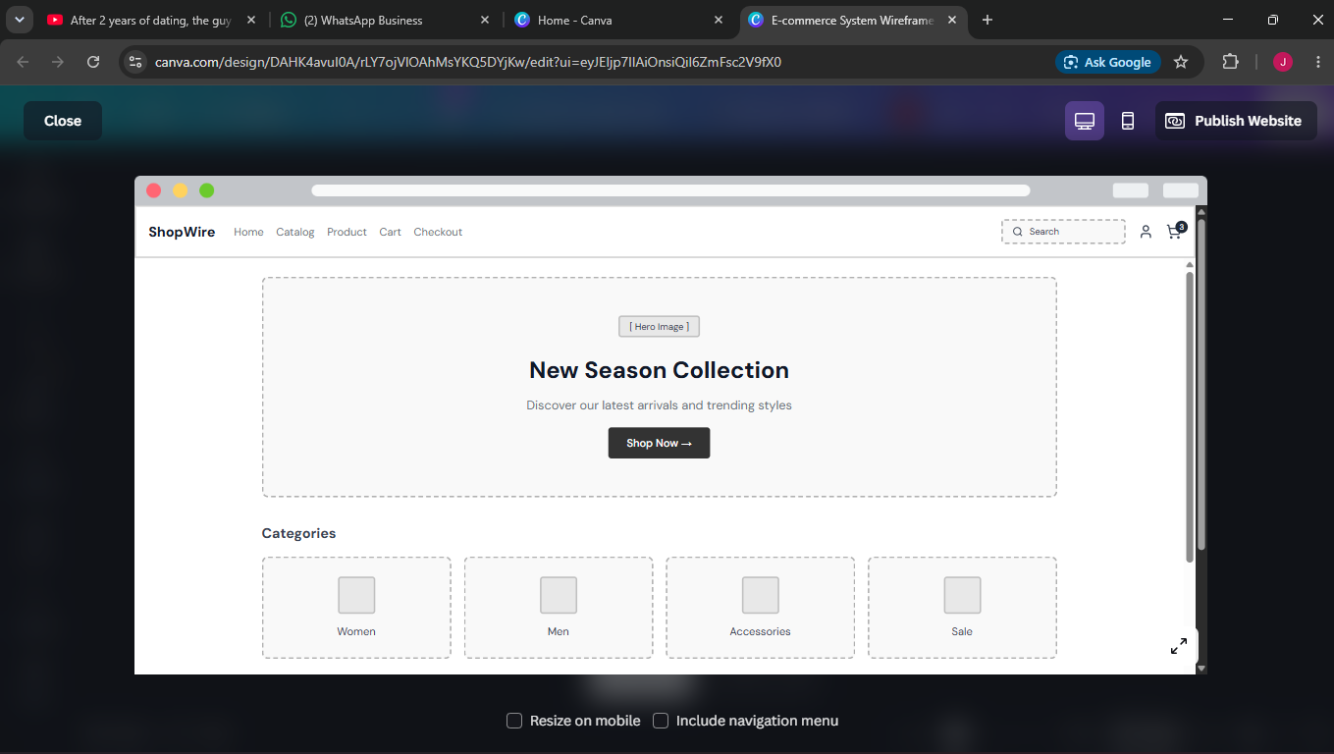

Fig 6: Wireframe (Homepage for ViatuBora)

Fig 7: Dashboard Layout Design
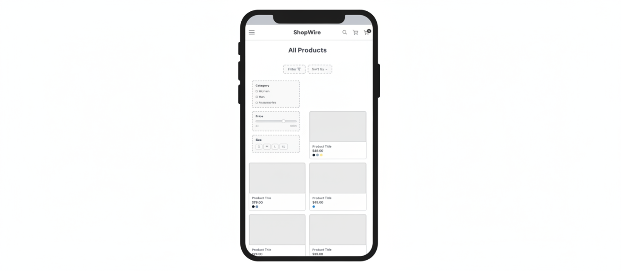Fig 8: Mobile View Mockup

Fig 9: Color Theme and Navigation Structure

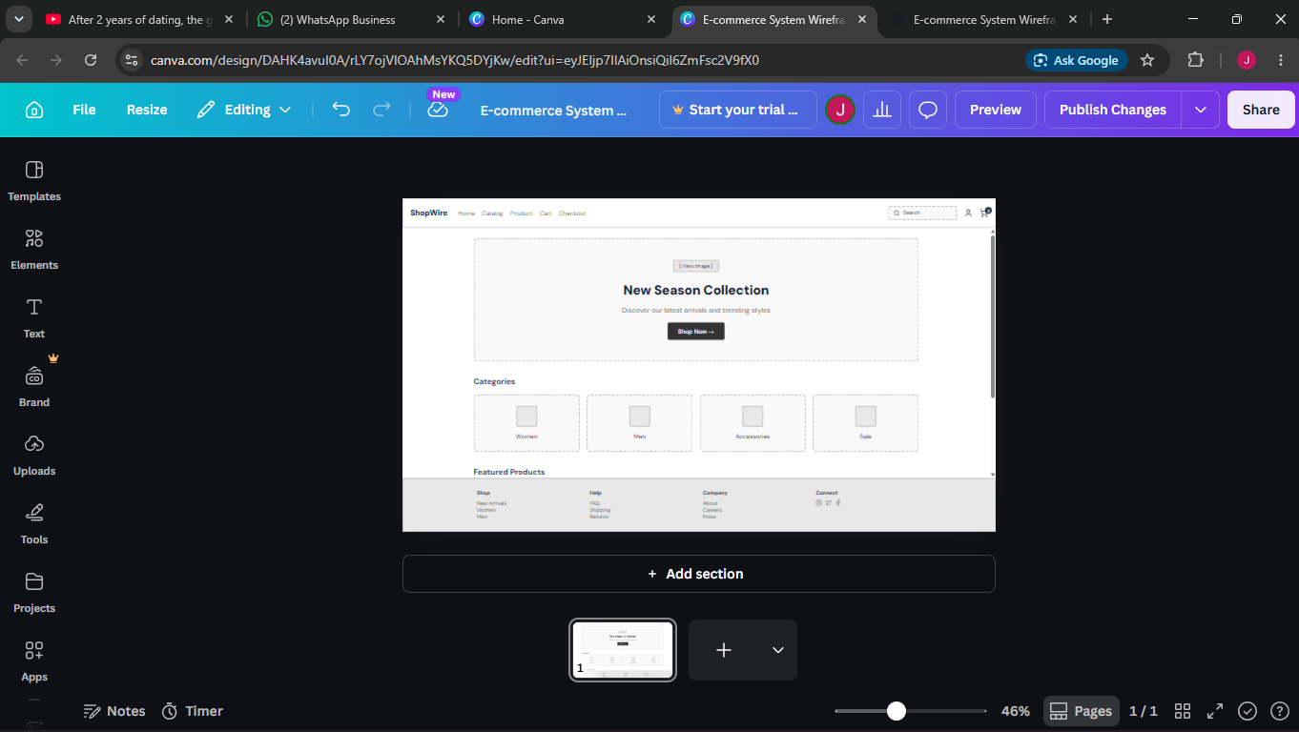
https://wireframedfgh.my.canva.site/e-commerce-system-wireframe

Fig 10: GUI Prototype in Canva

I designed a responsive UI with HTML5, CSS3, and Bootstrap for the ViatuBora storefront and admin panels. The dashboard layout was designed to reduce user clicks and improve accessibility for shoppers. The navigation menu was positioned on the left for easier scalability as more footwear categories and modules are added, which is evident in the sidebar.php implementation

WEEK3: Frontend Interaction and Backend Foundations

Fig 11: JavaScript Form Validation (e.g., preventing empty submissions on ViatuBora login)

Fig 12: Password Strength Checker

Fig 13: PHP Syntax Practice

Fig 14: Database Connection Script

Fig 15: Dynamic User Input Handling
I implemented dynamic user input handling to allow secure customer registration. The login validation prevents users from submitting empty forms. PHP was used to process form data while MySQL stored the records. In the register.php file, passwords are securely hashed using password_hash() before being written to the database to ensure baseline security requirements are met.

WEEK4: System Authentication and Session Management

Fig 16: User Registration Flow (register.php)

Fig 17: Secure Login Script (login.php)

Fig 18: Role-Based Redirection (Admin vs. Customer)

Fig 19: Session Initialization and Management

I developed a basic login system with PHP that connects to a database. I implemented secure session management to track authenticated users. As seen in login.php, the system enforces role-based access control, routing administrators to the dashboard.php inventory panel and standard customers to the index.php public store. This builds the core logic necessary for managing carts and checkouts later.

WEEK5: Designing the Product Catalog Database

Fig 20: Database Schema design in phpMyAdmin

Fig 21: Add Product Form (add-product.php)

Fig 22: Inventory Dashboard displaying database records (dashboard.php)

Fig 23: Edit and Delete functionalities (edit-product.php)
This week focused on database management and integrating backend logic. I connected to a database (MySQL) and performed CRUD operations (add, update, delete products) for the ViatuBora store. By leveraging prepared statements in files like insert-product.php and dashboard.php, I ensured the system was protected against SQL injection attacks, establishing a secure data pipeline for managing the footwear catalog

